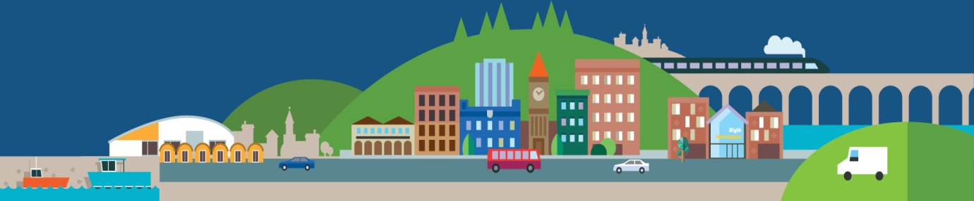
SUPERFAST BROADBAND IS HERE! FOR WORK OR PLAY CONNECT TODAY
iNorthumberland plans to bring superfast broadband to 95% of the county by 2017. However, unlike some previous improvements the faster speeds do not happen on their own. You need to contact an internet service provider in order to upgrade.
Many properties in Northumberland can already access superfast broadband speeds. To see if your property can, use the Availability Checker on our website: www.inorthumberland.org.uk/availability
Not all internet providers may offer superfast broadband services throughout the county. If our website says it is available but your provider tells you it is not please get in touch with us and we will try and help. Contact us at: info@inorthumberland.org.uk
Some people are put off upgrading because they think there will be an additional cost but it does not always cost more to upgrade. A lot depends on the speeds you want, the amount of data you will use and whether or not you are part way through a contract. For residential properties you can use the price comparison tool on our website to find the best superfast broadband deal available in your area. See www.inorthumberland.org.uk/deals for more information
Why should you upgrade? Traditional broadband struggles to cope with simultaneous demands. Connection to superfast broadband means that web pages load faster, streaming of music or video starts more quickly and you can say goodbye to timeouts and buffering. If you have a business it can reduce your marketing costs, grow your existing market, increase security and create trust in your services.
The second phase of fibre rollout has just commenced. Complete the form on our website www.inorthumberland.org.uk/pledge and if it becomes available in your area we will let you know. If your property is one of the approximately 10% that cannot order fibre broadband there are other options available. You may be interested in looking at satellite or wireless broadband options to improve your speed. There may be financial support for some of these services. Further information is available at: www.inorthumberland.org.uk/basic-broadband
What if you need help? 1 in 5 people in Northumberland don’t go online but there is lots of help out there. You can contact your local library: https://www.gov.uk/local-library-services, Northumberland Community Development Network: http://www.ncdn.org/, Blyth Resource & Initiative Centre (BRIC): https://www.bricblyth.org.uk/ Barclays Digital Eagles: www.barclays.co.uk or Sure Start Centres: https://www.gov.uk/find-sure-start-childrens-centre for more information.

